|  |
| --- |
|  |
|  |

**BAKERY STORE**

Report #2 – Screen Design

|  |  |  |
| --- | --- | --- |
| **Bakery Store** | | |
| **Group member** | Phạm Thị Minh Phương | SE03773 |
| Cao Anh Tuấn | SE03737 |
| Hoàng Anh Phương | SE03715 |
| Ngô Trung Kiên | SE03736 |
| Nguyễn Xuân Hà | SE03484 |
| **Supervisor** | Mr. Nguyễn Văn Sang | |
| **Project code** | BSO | |

**- Hanoi, 09/2017 -**

# SIGNATURE PAGE

AUTHOR: Ngô Trung Kiên 28/09/2017

Team member

REVIEWERS: Phạm Thị Minh Phương 30/09/2017

Project manager

APPROVAL: Nguyễn Văn Sang --/--/--17

Supervisor

Record of change

*A - Added M - Modified D – Deleted

|  |  |  |  |  |  |
| --- | --- | --- | --- | --- | --- |
| Effective Date | Changed Item | A,M,D | Change Description | Reason for Change | Rev. Number |
| 01/10/2017 | Create Screen Design | A | First version | Create Screen Design | 1.0 |
|  |  |  |  |  |  |
|  |  |  |  |  |  |
|  |  |  |  |  |  |
|  |  |  |  |  |  |
|  |  |  |  |  |  |
|  |  |  |  |  |  |
|  |  |  |  |  |  |
|  |  |  |  |  |  |
|  |  |  |  |  |  |
|  |  |  |  |  |  |
|  |  |  |  |  |  |
|  |  |  |  |  |  |
|  |  |  |  |  |  |
|  |  |  |  |  |  |
|  |  |  |  |  |  |
|  |  |  |  |  |  |
|  |  |  |  |  |  |
|  |  |  |  |  |  |
|  |  |  |  |  |  |
|  |  |  |  |  |  |
|  |  |  |  |  |  |
|  |  |  |  |  |  |
|  |  |  |  |  |  |
|  |  |  |  |  |  |

Table of Contents

SIGNATURE PAGE 1

Introduction 4

1.1 Purpose 4

1.2 Definitions, Acronyms and Abbreviations 4

1.3 Overview 4

2 Screen 4

2.1 User 4

2.2 ADMIN 6

2.3 Staff 23

# Introduction

## Purpose

To ensure consistency and simplicity in detailed design across all displays within a product interface, as well as across other products used by the same users. Definitions, acronyms, abbreviations, references and overview of BSO website.

## Definitions, Acronyms and Abbreviations

|  |  |  |
| --- | --- | --- |
| Abbreviations | Description | Comment |
| BSO | Bakery store online |  |
| Q&A | Question and Answer |  |

1. Definitions, Acronyms and Abbreviations

## Overview

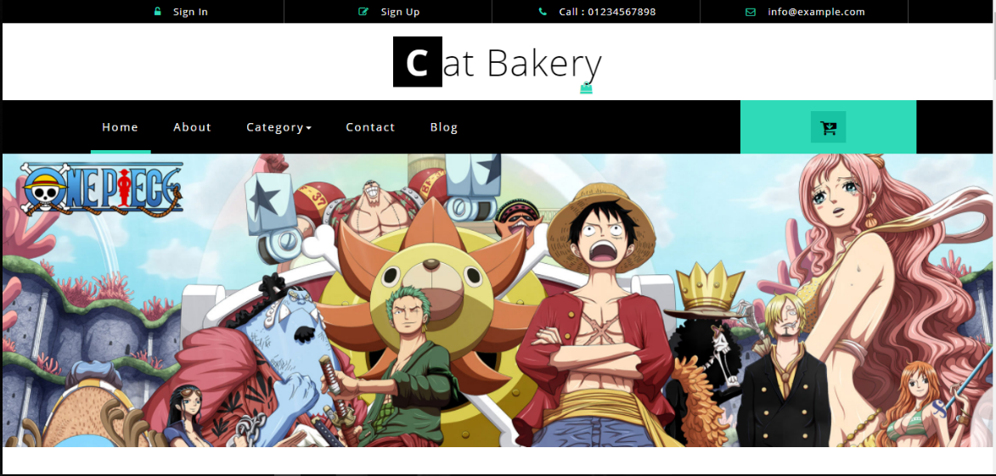

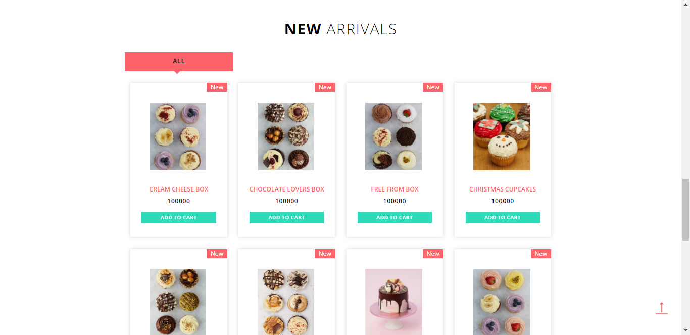

# Screen

## User

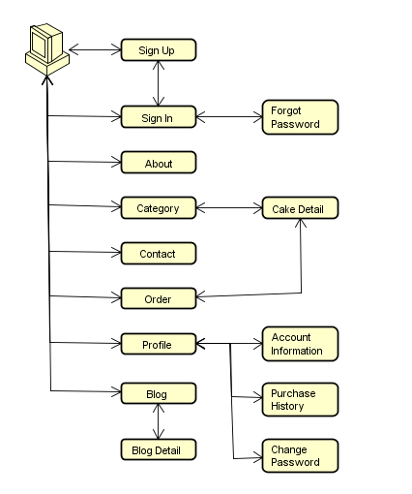

1. User screen flow

### Sign In

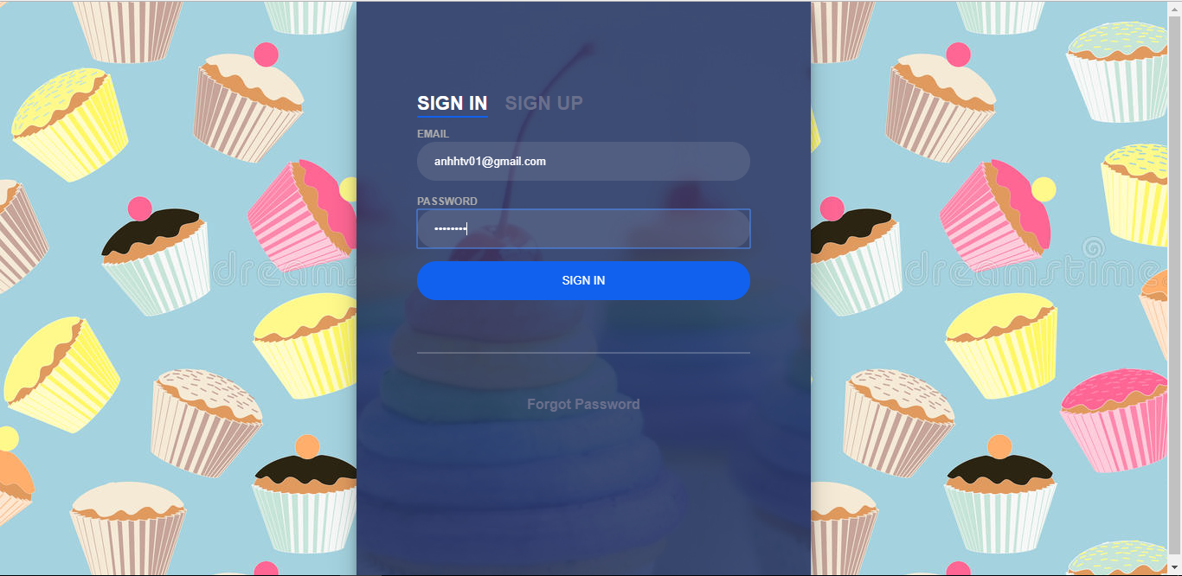

1. Login **screen**

|  |  |  |  |  |  |  |
| --- | --- | --- | --- | --- | --- | --- |
| No | Field name | Type | Require | Mandatory | Max-Length | Description |
| 1 | Sign in | Label | Click | Y |  | From Sign in |
| 2 | Sign up | Label | Click | Y |  | From Sign up |
| 3 | Email | Text box | Email | Y |  | Email of User |
| 4 | Password | Text box | Type | Y |  | Password |
| 5 | Sign in | Button | Click | Y |  | Login |
| 6 | Forgot Pasword | Link | Click | Y |  | Forgot Password |

1. R**egister** screen

### Sign up

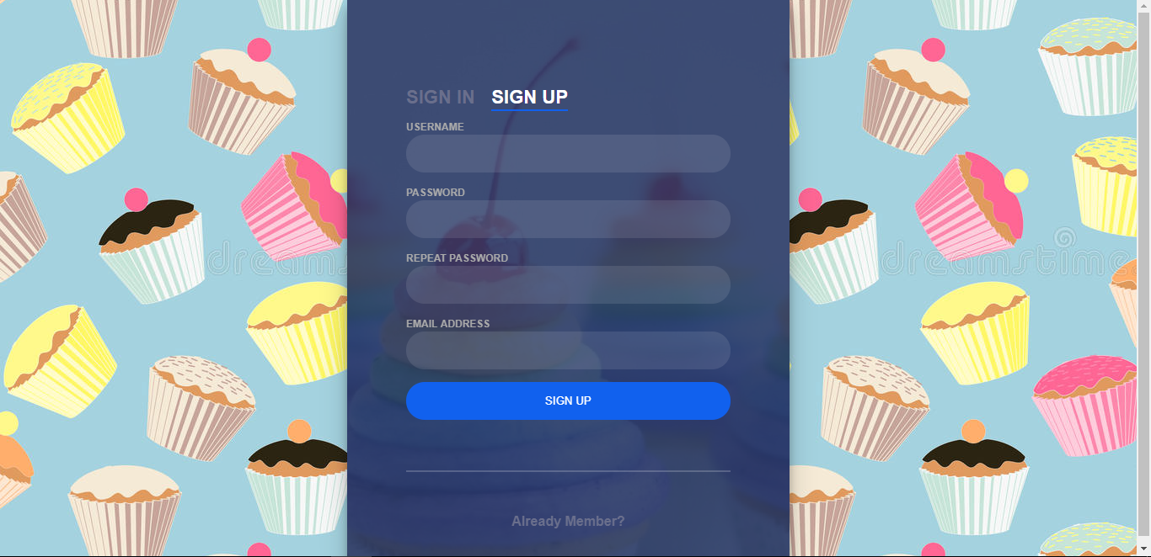

1. Sign up Screen

|  |  |  |  |  |  |  |
| --- | --- | --- | --- | --- | --- | --- |
| No | Field name | Type | Require | Mandatory | Max-Length | Description |
| 1 | Sign in | Label | Click | Y |  | From Sign in |
| 2 | Sign up | Label | Click | Y |  | From Sign up |
| 3 | UserName | Text |  | Y |  | User Name |
| 4 | Password | Text | Password | Y |  | Password |
| 5 | Repeat Password | Text | Pass word |  |  | Repeat Password |
| 6 | Email | Text | Email | Y |  | Email of User |
| 7 | Sign up | Button | Click | Y |  | Sign up |
| 8 | Already Member | Link | Click | Y |  | Back to Sign In |

1. Sign Up Screen

### Home



1. Home screen 1



1. Home screen 2

|  |  |  |  |  |  |  |
| --- | --- | --- | --- | --- | --- | --- |
| No | Field name | Type | Require | Mandatory | Max-Length | Description |
| 1 | Home | Tab | Click | Y |  | Home Page |
| 2 | About | Tab | Click | Y |  | About Shop |
| 3 | Category | Drowdownlist | Click | Y |  | Display category of cake |
| 4 | Contact | Tab | Click | Y |  | Contact of shop |
| 5 | Icon shopping cart | Button | Click | Y |  | Display shopping cart |
| 6 | Event | Panel | Click | Y |  | Display event detail |
| 7 | List new arrival |  | Click | Y |  | Display cake detail |
| 8 | Add to cart | Button | Click | Y |  | Add to shopping cart |

### About

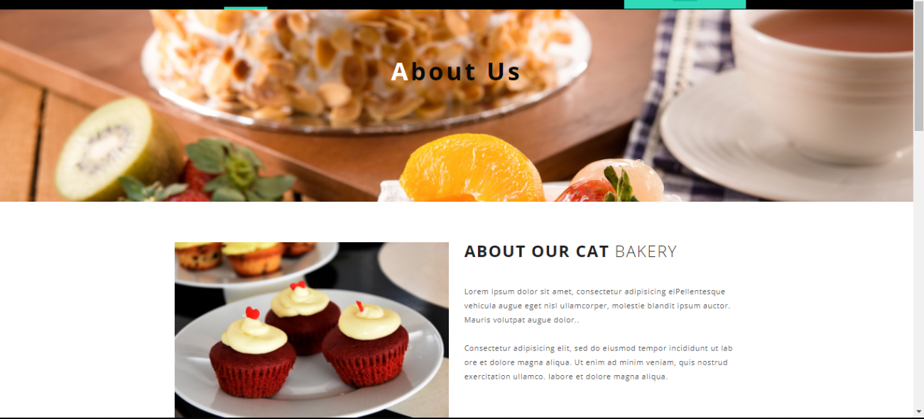

1. About Us screen

|  |  |  |  |  |  |  |
| --- | --- | --- | --- | --- | --- | --- |
| No | Field name | Type | Require | Mandatory | Max-Length | Description |
| 1 | Home | Tab | Click | Y |  | Home Page |
| 2 | About | Tab | Click | Y |  | About Shop |
| 3 | Category | Drowdownlist | Click | Y |  | Display category of cake |
| 4 | Contact | Tab | Click | Y |  | Contact of shop |
| 5 | Icon shopping cart | Button | Click | Y |  | Display shopping cart |
| 6 | About our cat bakery | Label |  | Y |  | About us |

1. About Us

### Category

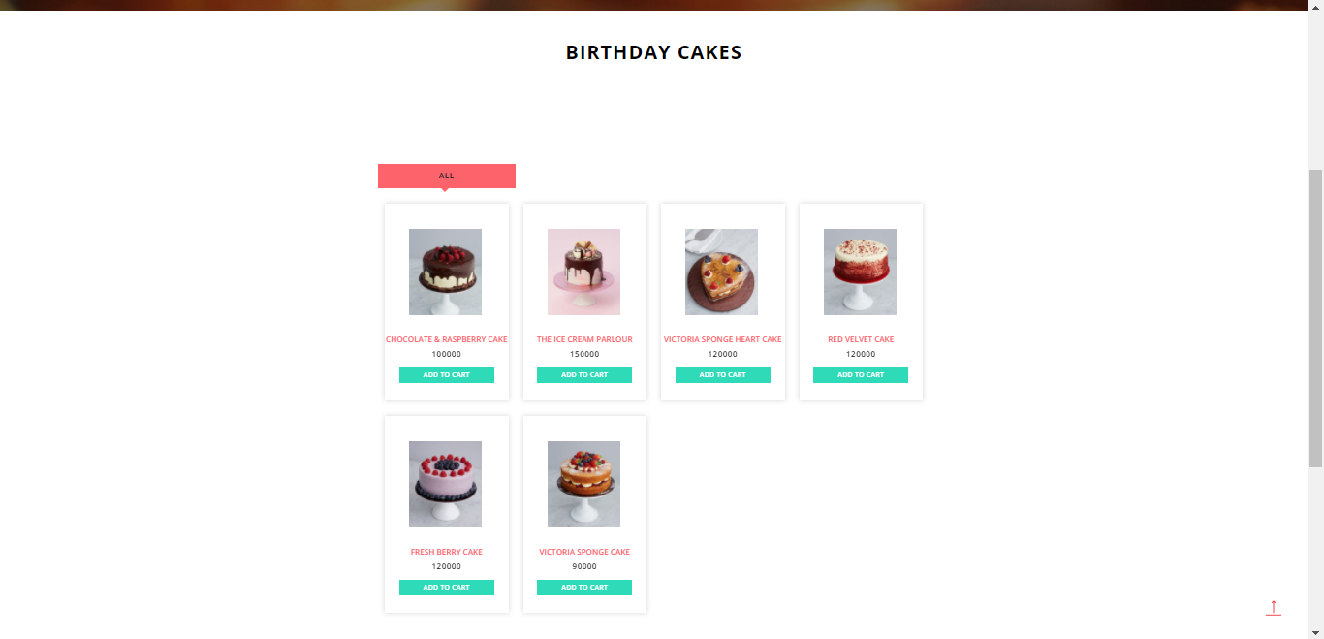

1. Category screen

|  |  |  |  |  |  |  |
| --- | --- | --- | --- | --- | --- | --- |
| No | Field name | Type | Require | Mandatory | Max-Length | Description |
| 1 | Home | Tab | Click | Y |  | Home Page |
| 2 | About | Tab | Click | Y |  | About Shop |
| 3 | Category | Drowdownlist | Click | Y |  | Display category of cake |
| 4 | Contact | Tab | Click | Y |  | Contact of shop |
| 5 | Icon shopping card | Button | Click | Y |  | Display shopping card |
| 6 | Event | Panel | Click | Y |  | Display event detail |
| 7 | List new arrival |  | Click | Y |  | Display cake detail |
| 8 | Add to cart | Button | Click | Y |  | Add to shopping cart |

1. Category

### Contact

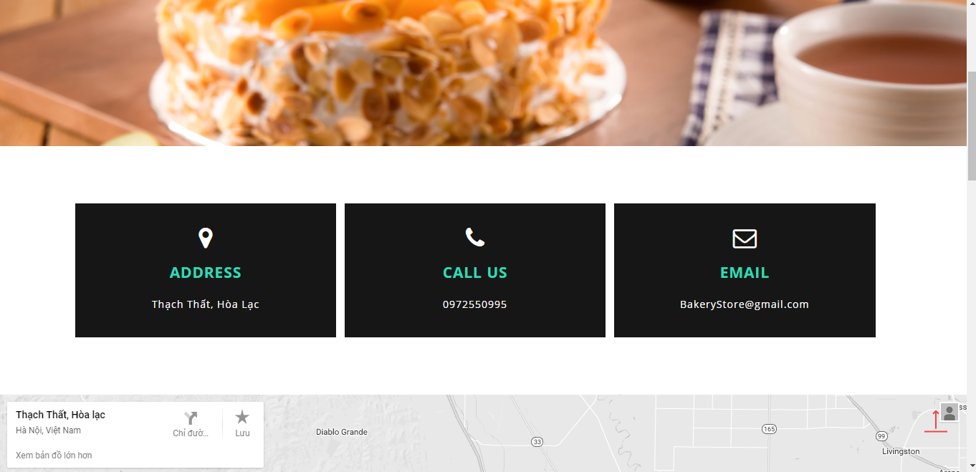

1. Contact Screen

|  |  |  |  |  |  |  |
| --- | --- | --- | --- | --- | --- | --- |
| No | Field name | Type | Require | Mandatory | Max-Length | Description |
| 1 | Home | Tab | Click | Y |  | Home Page |
| 2 | About | Tab | Click | Y |  | About Shop |
| 3 | Category | Drowdownlist | Click | Y |  | Display category of cake |
| 4 | Contact | Tab | Click | Y |  | Contact of shop |
| 5 | Icon shopping cart | Button | Click | Y |  | Display shopping cart |
| 6 | Contact Us | Label |  | Y |  | Contact Us |

1. Contact

### Order

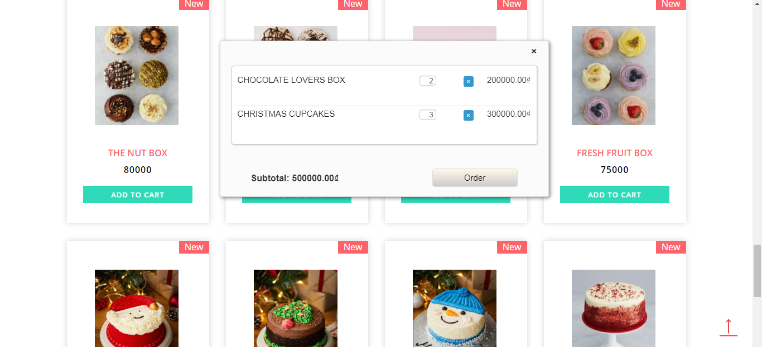

1. Shopping Cart Screen

|  |  |  |  |  |  |  |
| --- | --- | --- | --- | --- | --- | --- |
| No | Field name | Type | Require | Mandatory | Max-Length | Description |
| 1 | List cake | Table |  | Y |  | List cake |
| 2 | Text box | Text |  | Y |  | Input quantiry of cake |
| 3 | Icon (x) | Button | Click | Y |  | Remove Cake |
| 4 | Subtotal | Text |  | Y |  | Price total |
| 5 | Order | Button | Click | Y |  | Order |

1. Shopping Cart

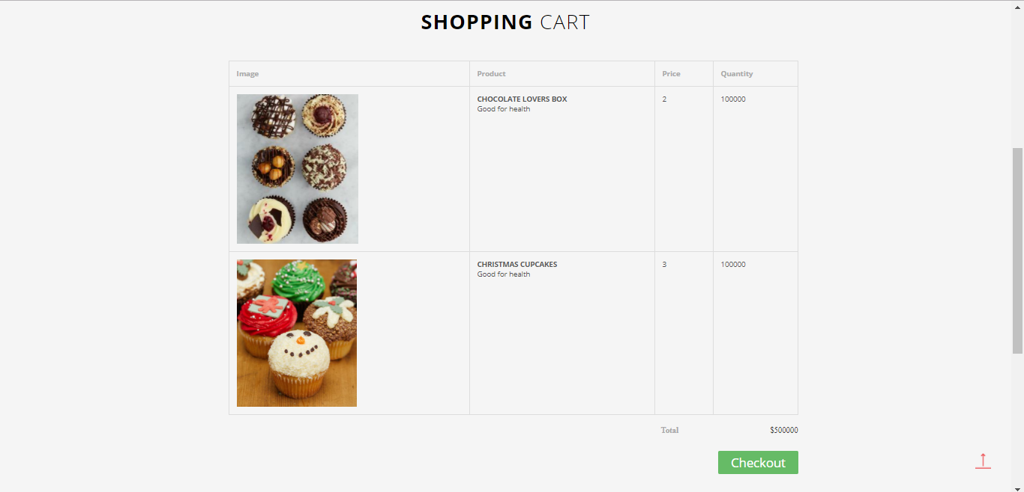

1. Shopping Cart Detail Screen

|  |  |  |  |  |  |  |
| --- | --- | --- | --- | --- | --- | --- |
| No | Field name | Type | Require | Mandatory | Max-Length | Description |
| 1 | Home | Tab | Click | Y |  | Home Page |
| 2 | About | Tab | Click | Y |  | About Shop |
| 3 | Category | Drowdownlist | Click | Y |  | Display category of cake |
| 4 | Contact | Tab | Click | Y |  | Contact of shop |
| 5 | Icon shopping cart | Button | Click | Y |  | Display shopping cart |
| 6 | List Cake | Table |  | Y |  | List Cake |
| 7 | Total | Text |  | Y |  | Price total |
| 8 | Checkout | Button | Click | Y |  | Check out |

1. Shopping Cart Detail

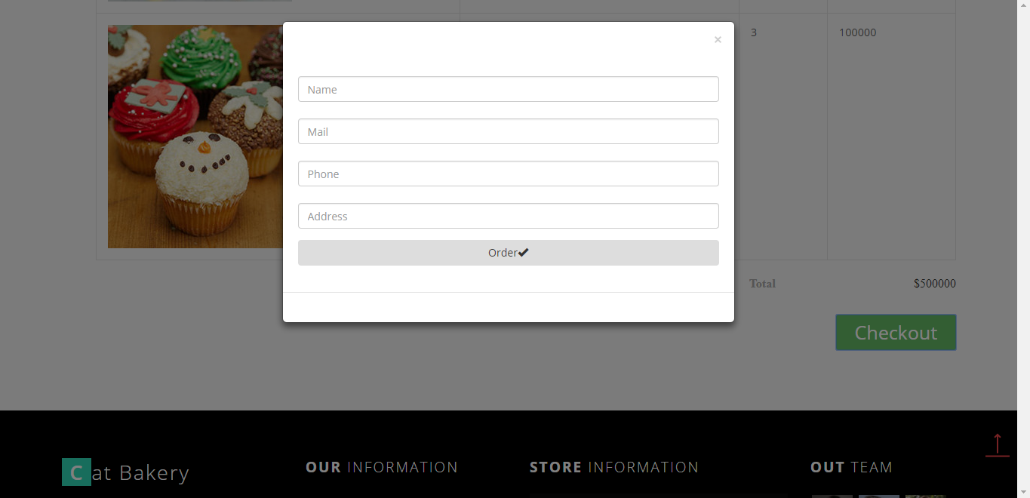

1. Checkout Screen

|  |  |  |  |  |  |  |
| --- | --- | --- | --- | --- | --- | --- |
| No | Field name | Type | Require | Mandatory | Max-Length | Description |
| 1 | Name | Text |  | Y |  | Name of Customer |
| 2 | Mail | Text |  | Y |  | Mail of Customer |
| 3 | Phone | Text |  | Y |  | Phone of Customer |
| 4 | Address | Text |  | Y |  | Address of Customer |
| 5 | Order | Button | Click |  |  | Order |

### Profile

#### **Account information**

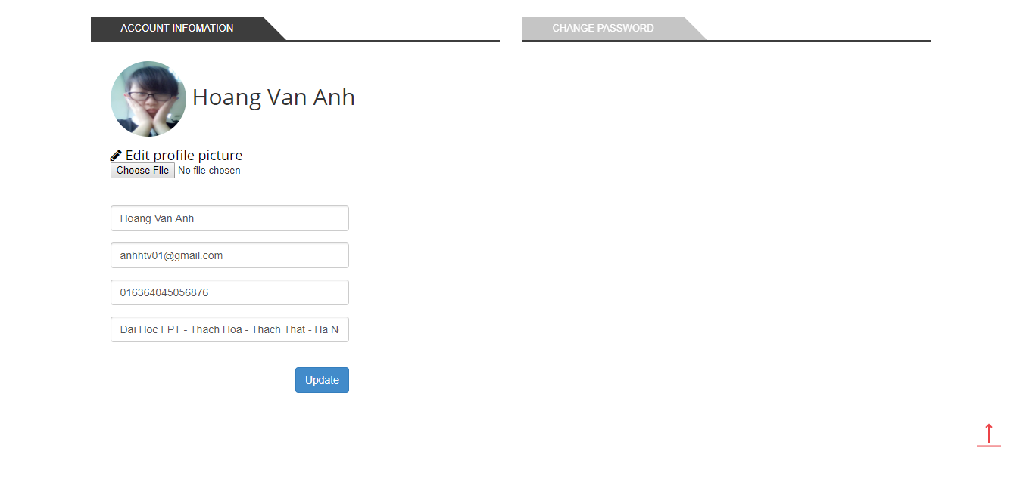

1. Account Information screen

|  |  |  |  |  |  |  |
| --- | --- | --- | --- | --- | --- | --- |
| No | Field name | Type | Require | Mandatory | Max-Length | Description |
| 1 | Account Information | Tab | Click | Y |  | Tab Information of account |
| 2 | Purchase history | Tab | Click | Y |  | Tab purchase history |
| 3 | Change Password | Tab | Click | Y |  | Tab Change Password |
| 4 | Choose File | Button | Click | Y |  | Select Photo |
| 5 | Name Customer | Text |  | Y |  | Name of Customer |
| 6 | Email | Text |  | Y |  | Email of Customer |
| 7 | Phone Number | Text |  | Y |  | Phone of Customer |
| 8 | Address | Text |  | Y |  | Address of Customer |
| 9 | Update | Button | Click | Y |  | Update |

1. Account Information

#### **Purchase history**

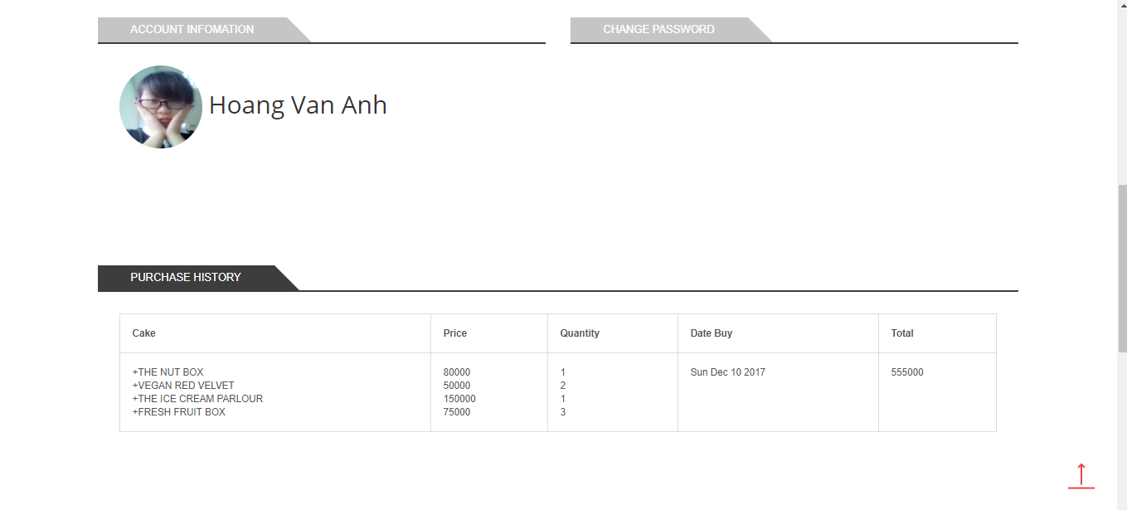

1. Purchase History Screen

|  |  |  |  |  |  |  |
| --- | --- | --- | --- | --- | --- | --- |
| No | Field name | Type | Require | Mandatory | Max-Length | Description |
| 1 | Account Information | Tab | Click | Y |  | Information of account |
| 2 | Purchase History | Tab | Click | Y |  | Purchase History |
| 3 | Change Password | Tab | Click | Y |  | Change Password |
| 4 | List Purchase History | Table |  | Y |  | List Purchase History |

1. Purchase History

#### **Change Password**

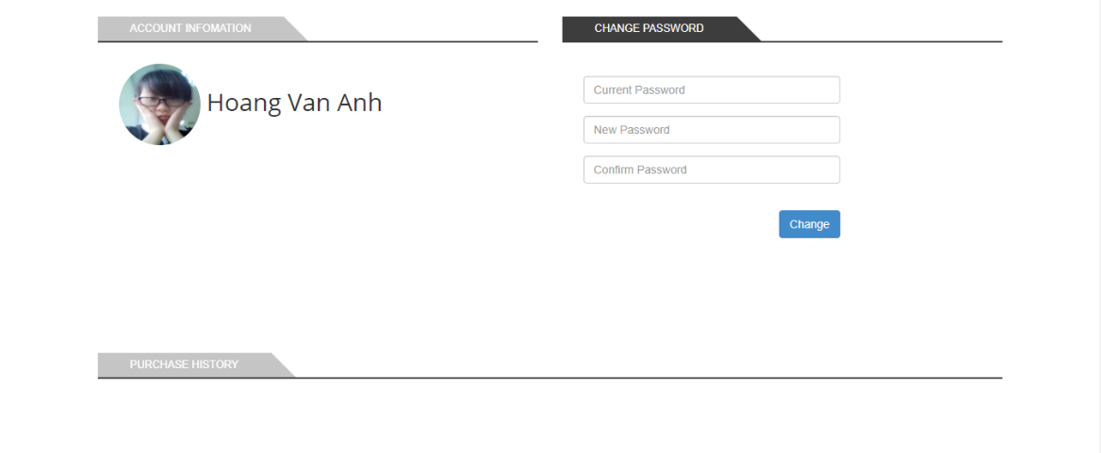

1. Change Password screen

|  |  |  |  |  |  |  |
| --- | --- | --- | --- | --- | --- | --- |
| No | Field name | Type | Require | Mandatory | Max-Length | Description |
| 1 | Old Password | Text |  | Y |  | Old Password |
| 2 | New Password | Text |  | Y |  | New Password |
| 3 | Repeat Password | Text |  | Y |  | Repeat Password |
| 4 | Change Password | Button | Click | Y |  | Change Password |

1. Change Password

### Blog

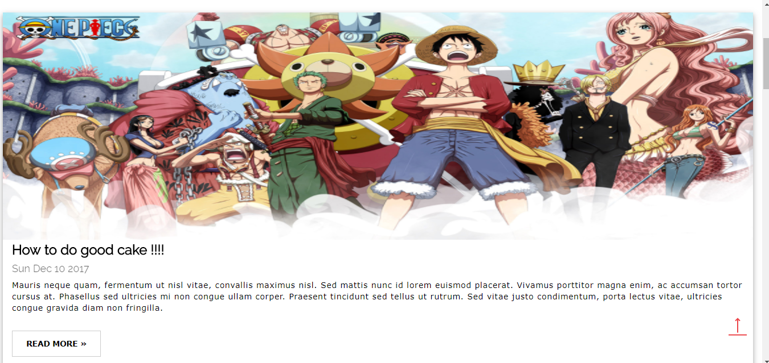

1. Blog Screen

|  |  |  |  |  |  |  |
| --- | --- | --- | --- | --- | --- | --- |
| No | Field name | Type | Require | Mandatory | Max-Length | Description |
| 1 | List Blog | List |  | Y |  | List blog |
| 2 | Read more | Button | Click | Y |  | View Detail |

1. Blog

#### Blog Detail

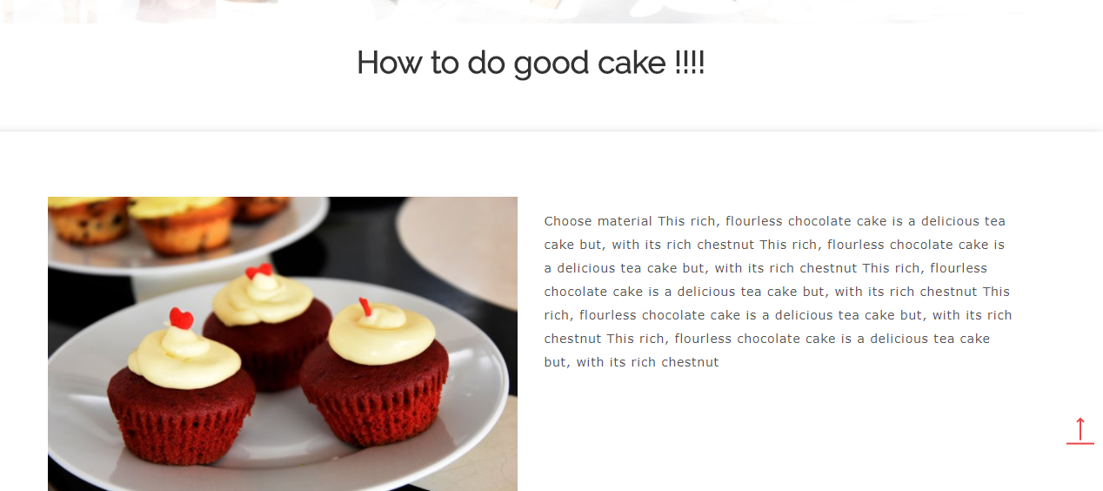

1. Blog Detail

## ADMIN

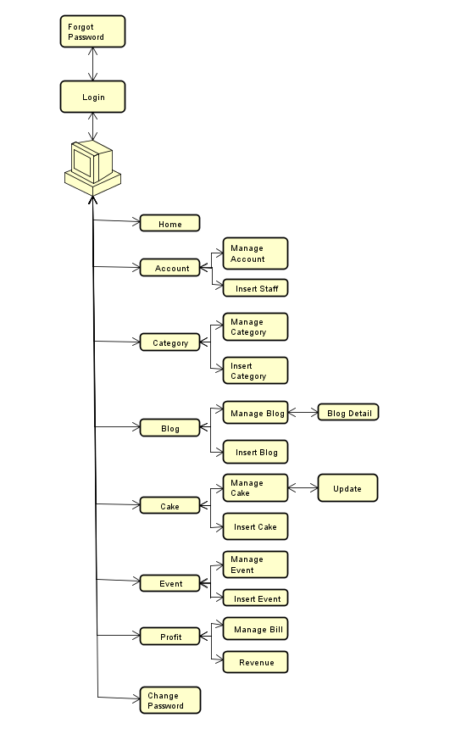

1. Admin screen flow

### Sign In

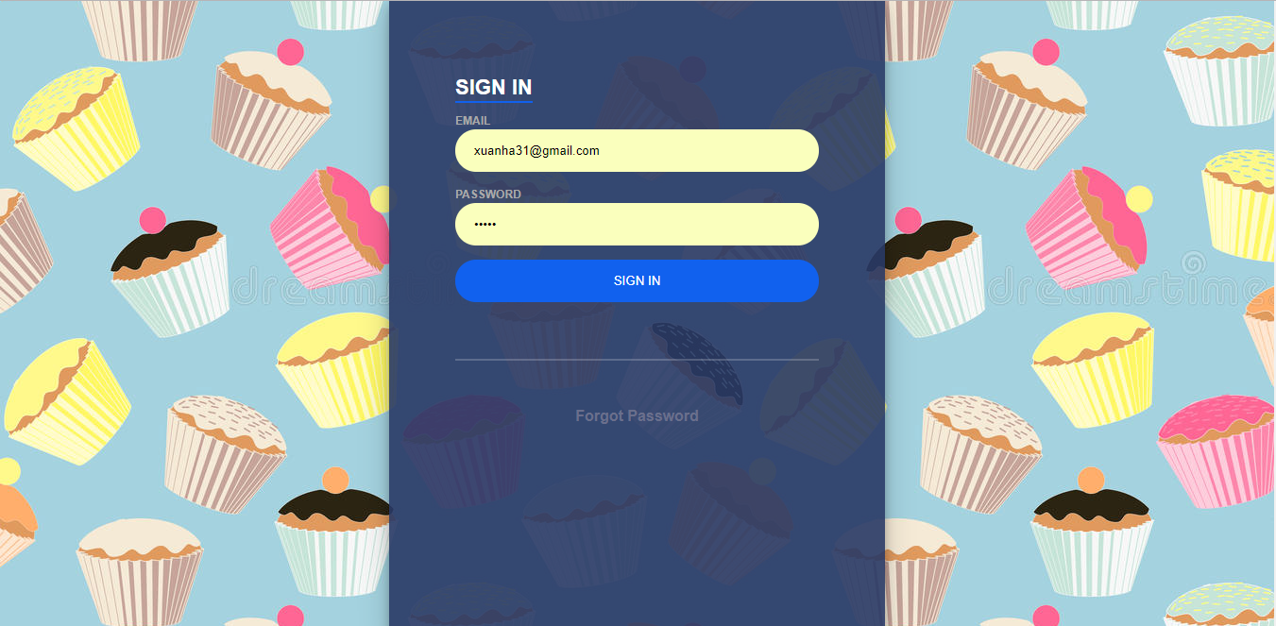

1. Login screen

|  |  |  |  |  |  |  |
| --- | --- | --- | --- | --- | --- | --- |
| No | Field name | Type | Require | Mandatory | Max-Length | Description |
| 1 | Email | Text box | Email | Y |  | Email of Admin |
| 2 | Password | Text box | Type | Y |  | Password of Admin |
| 3 | Sign in | Button | Click | Y |  | Login |
| 4 | Forgot Pasword | Link | Click | Y |  | Forgot Password |

1. Login

### Forgot Password

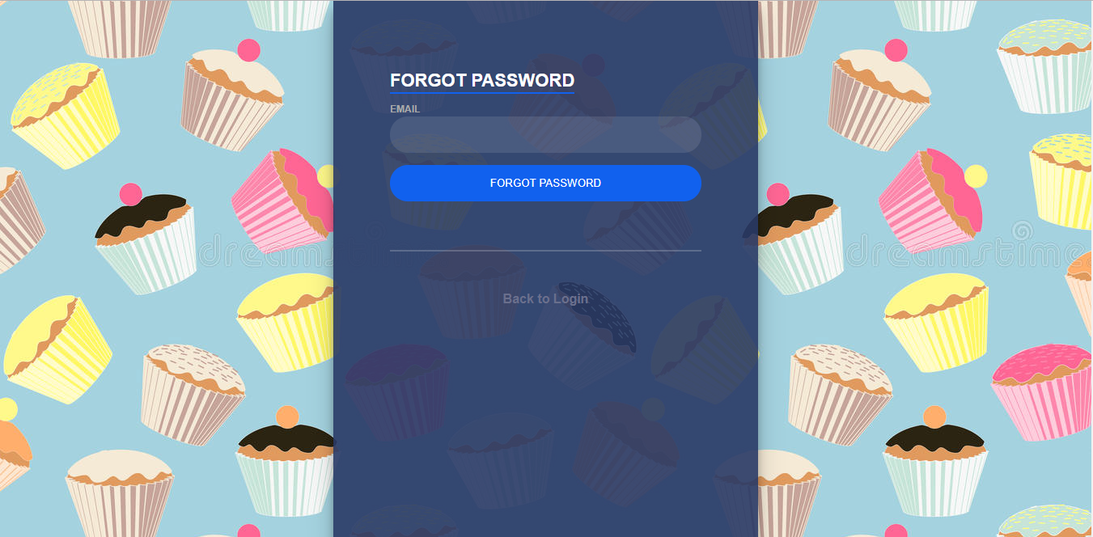

1. Forgot Password screen

|  |  |  |  |  |  |  |
| --- | --- | --- | --- | --- | --- | --- |
| No | Field name | Type | Require | Mandatory | Max-Length | Description |
| 1 | Email | Text box | Email | Y |  | Email |
| 2 | Forgot Password | Button | Click | Y |  | Forgot Password |
| 3 | Back to login | Link | Click | Y |  | Back to login |

1. Forgot Password

### Account

#### **Manage Account**

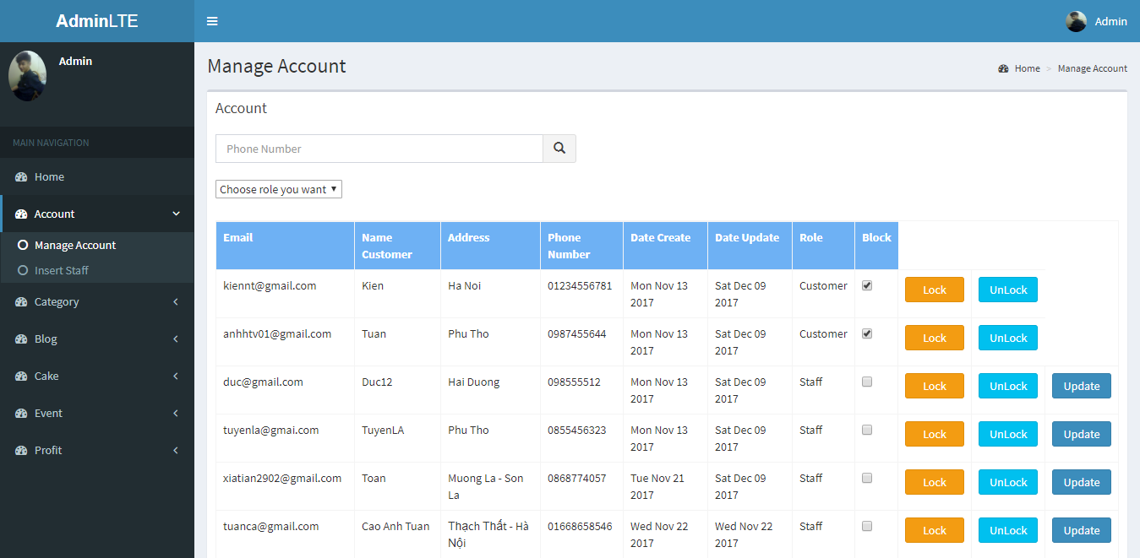

1. Manage Account screen

|  |  |  |  |  |  |  |
| --- | --- | --- | --- | --- | --- | --- |
| No | Field name | Type | Require | Mandatory | Max-Length | Description |
| 1 | Search | Input Text | Input Phone number | Y |  | Search by phone number of account |
| 2 | Icon Search | Button | Click | Y |  | Icon Search |
| 3 | Choose role you want | Drop Downlist | Click | Y |  | Search by role |
| 4 | List Account | Table |  | Y |  | List Account |
| 5 | Block | Check box |  | Y |  | Block account |
| 6 | Lock | Button | Click | Y |  | Button Lock Account |
| 7 | Unlock | Button | Click | Y |  | Button Unlock Account |

Table 2.13.1: Manage Account

#### **Insert Staff**

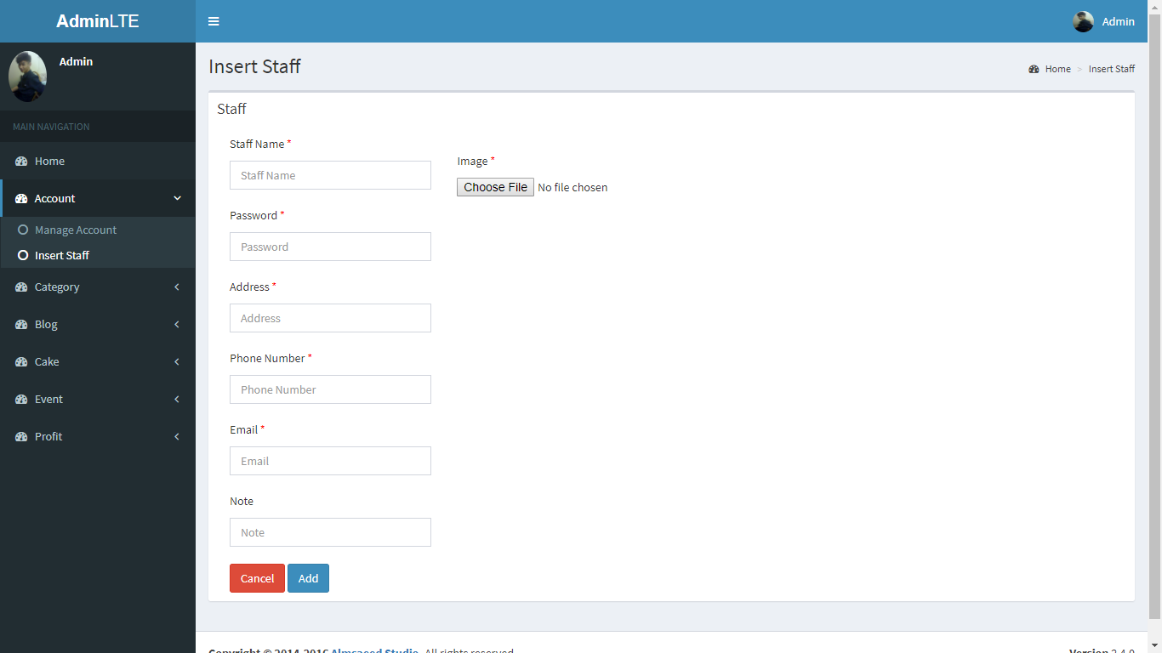

1. Insert Staff screen

|  |  |  |  |  |  |  |
| --- | --- | --- | --- | --- | --- | --- |
| No | Field name | Type | Require | Mandatory | Max-Length | Description |
| 1 | Staff name | Text |  | Y |  | Staff name |
| 2 | Password | Text |  | Y |  | Password of staff |
| 3 | Address | Text |  | Y |  | Address of staff |
| 4 | Phone Number | Text |  | Y |  | Phone Number of Staff |
| 5 | Email | Text |  | Y |  | Email of staff |
| 6 | Note | Text |  | N |  | Other information |
| 7 | Choose File | Button | Click | Y |  | Select photo |
| 8 | Cancel | Button | Click | Y |  | Cancel and back manage account page |
| 9 | Add | Button | Click | Y |  | Add Staff |

1. Insert Staff

### Category

#### **Manage Category**

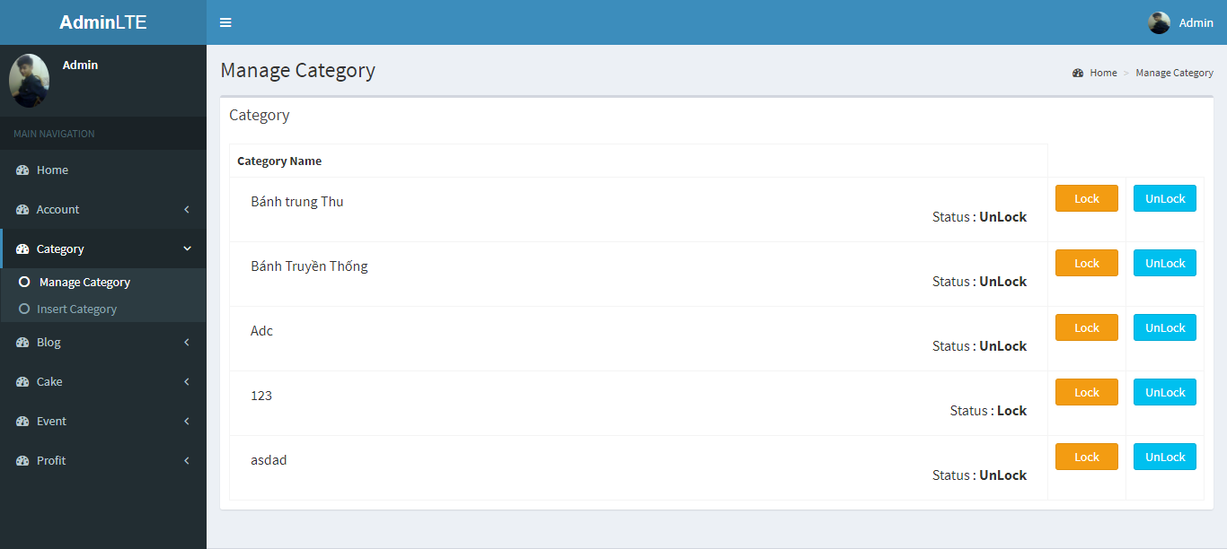

1. Mangage Category screen

|  |  |  |  |  |  |  |
| --- | --- | --- | --- | --- | --- | --- |
| No | Field name | Type | Require | Mandatory | Max-Length | Description |
| 1 | List Category | Table |  | Y |  | List Category |
| 2 | Lock | Button |  | Y |  | Lock Category |
| 3 | UnLock | Button |  | Y |  | UnLock Category |

1. Mangage Category

#### **Insert Category**

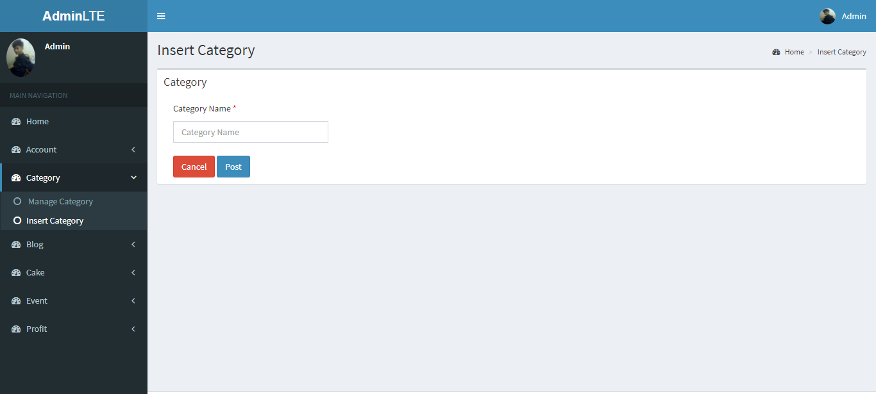

1. Insert Category screen

|  |  |  |  |  |  |  |
| --- | --- | --- | --- | --- | --- | --- |
| No | Field name | Type | Require | Mandatory | Max-Length | Description |
| 1 | Category Name | Text |  | Y |  | List projects |
| 2 | Cancle | Button | Click | Y |  | Cancle and back to manage category |
| 3 | Post | Button | Click | Y |  | Post Category |

1. Insert Catgegory

### Blog

#### **Manage Blog**

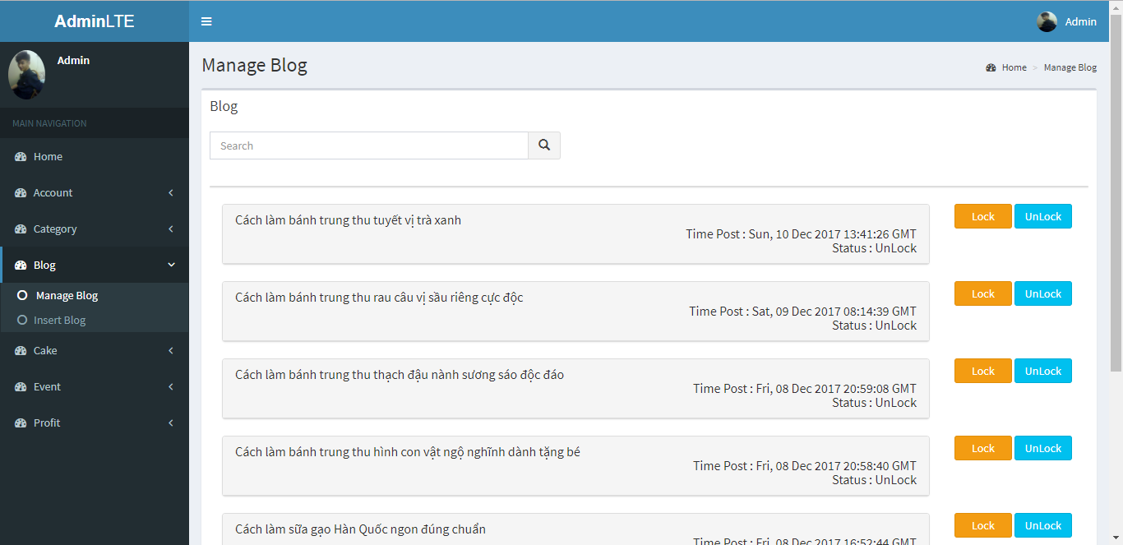

1. Manage Blog screen

|  |  |  |  |  |  |  |
| --- | --- | --- | --- | --- | --- | --- |
| No | Field name | Type | Require | Mandatory | Max-Length | Description |
| 1 | Search | Text |  | Y |  | Search by name blog |
| 2 | Search (icon) | Button | Click | Y |  | Icon search |
| 3 | List Blog | List | Click | Y |  | List blog (click to view detail blog |
| 4 | Lock | Button | Click | Y |  | Lock blog |
| 5 | UnLock | Button | Click | Y |  | Unlock blog |

1. Manage Blog

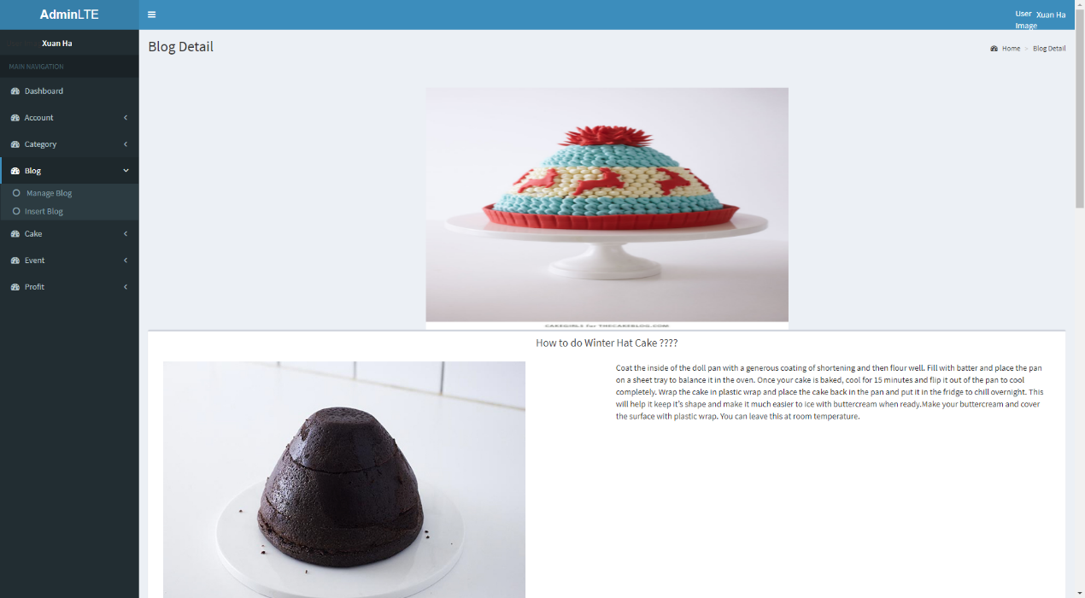

1. Blog Detail Screen

#### **Insert Blog**

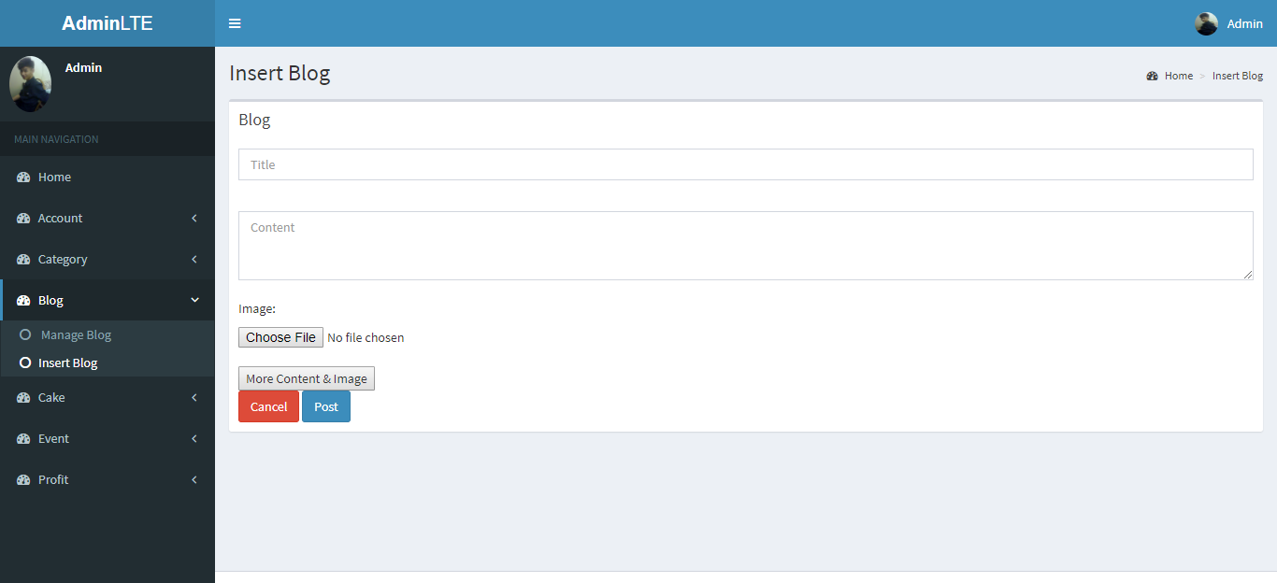

1. Insert Blog Screen

|  |  |  |  |  |  |  |
| --- | --- | --- | --- | --- | --- | --- |
| No | Field name | Type | Require | Mandatory | Max-Length | Description |
| 1 | Title | Text |  | Y |  | Title blog |
| 2 | Content | Text |  | Y |  | Content blog |
| 3 | Choose File | Button | Click | Y |  | Select Photo |
| 4 | More Content & Image | Button | Click |  |  | More Content and Image |
| 5 | Cancle | Button | Click | Y |  | Cancle and back to manage blog |
| 6 | Post | Button | Click | Y |  | Post Blog |

1. Insert Blog

### Cake

#### **Manage Cake**

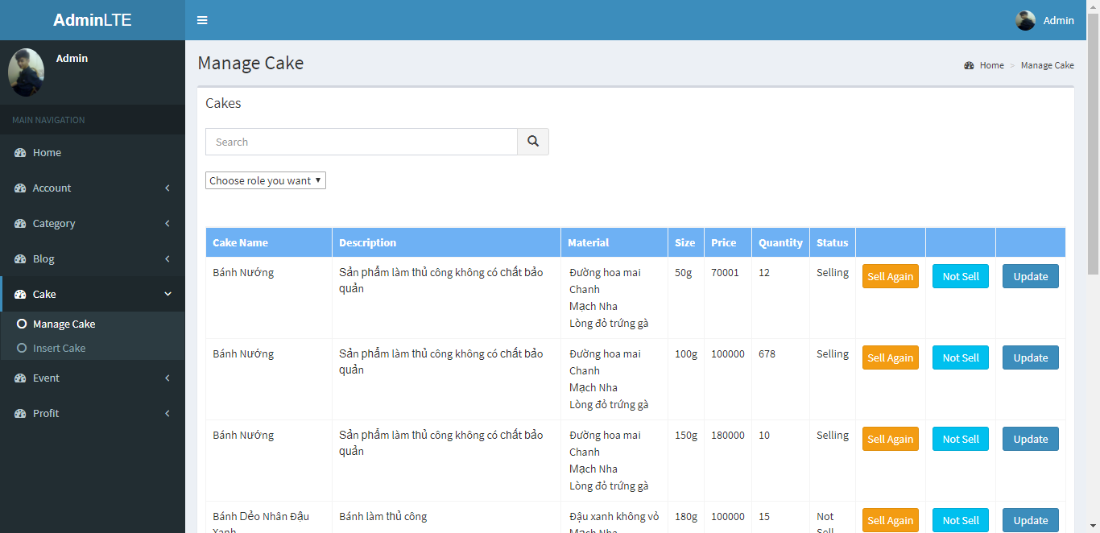

1. Manage Cake screen
2. Cake management

|  |  |  |  |  |  |  |
| --- | --- | --- | --- | --- | --- | --- |
| No | Field name | Type | Require | Mandatory | Max-Length | Description |
| 1 | Search | Input Text |  | Y |  | Search by name |
| 2 | Icon Search | Button | Click | Y |  | Icon Search |
| 3 | Choose role you want | Drop Downlist | Click | Y |  | Search by role |
| 4 | List Cake | Table |  | Y |  | List Cake |
| 5 | Sell Again | Button | Click | Y |  | Updates Status |
| 6 | Not Sell | Button | Click | Y |  | Updates Status |
| 7 | Update | Button | Click | Y |  | Update cake |

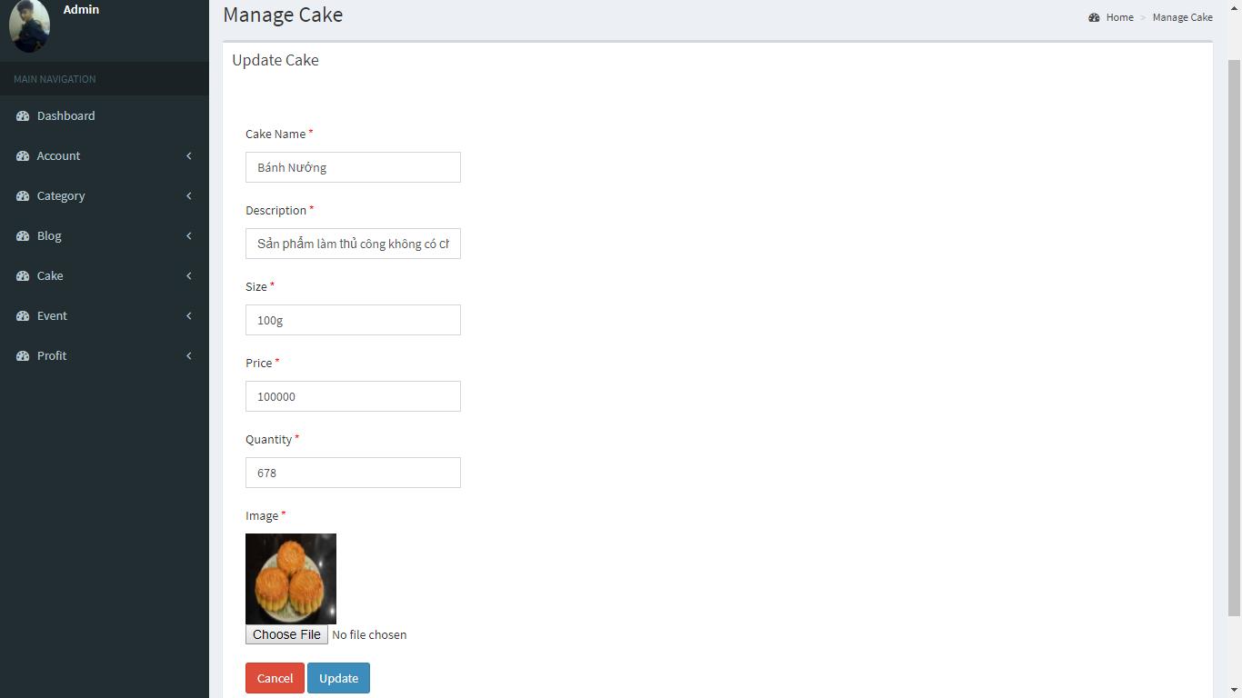

1. Updates Cake Screen

|  |  |  |  |  |  |  |
| --- | --- | --- | --- | --- | --- | --- |
| No | Field name | Type | Require | Mandatory | Max-Length | Description |
| 1 | Cake Name | Text |  | Y |  | Cake Name |
| 2 | Decsription | Text |  | Y |  | Decsription Cake |
| 3 | Size | Text |  | Y |  | Size Cake |
| 4 | Price | Text |  | Y |  | Price of cake |
| 5 | Quantity | Text |  | Y |  | Quantity |
| 6 | Choose File | Button | Click | Y |  | Select photo |
| 7 | Cancel | Button | Click | Y |  | Cancel and back manage Cake |
| 8 | Update | Button | Click | Y |  | Update cake |

1. Update cake

#### **Insert Cake**

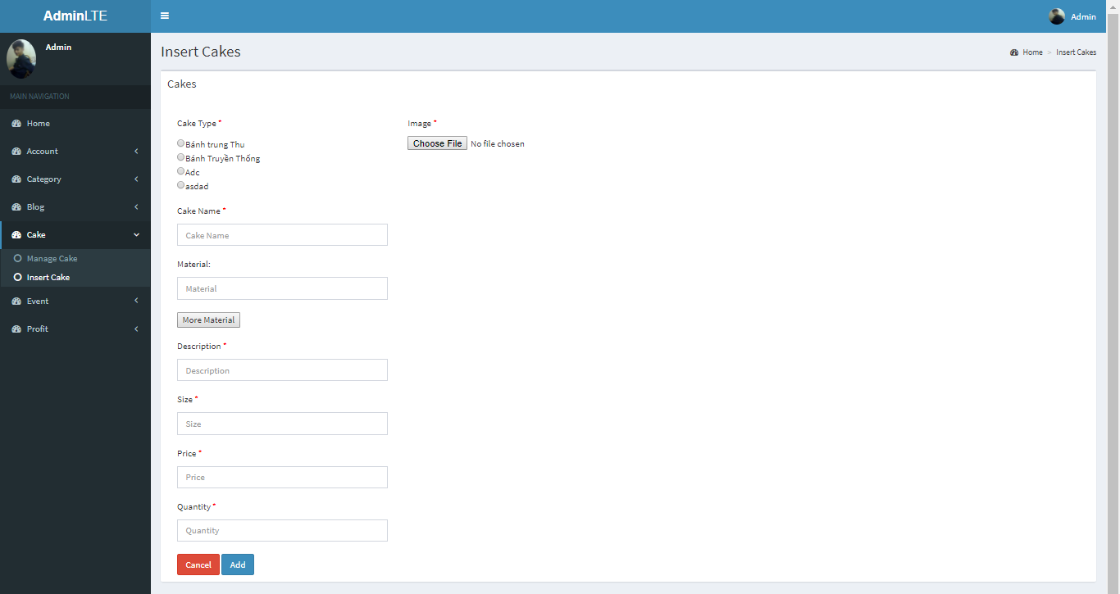

1. Insert Cake Screen

|  |  |  |  |  |  |  |
| --- | --- | --- | --- | --- | --- | --- |
| No | Field name | Type | Require | Mandatory | Max-Length | Description |
| 1 | Cake Type | Check box | Click | Y |  | Cake Type |
| 2 | Cake Name | Text |  | Y |  | Cake Name |
| 3 | Material | Text |  | Y |  | Material |
| 4 | More Material | Button | Click | Y |  | More Material |
| 5 | Description | Text |  | Y |  | Description cake |
| 6 | Size | Text |  | Y |  | Size cake |
| 7 | Price | Text |  | Y |  | Price of cake |
| 8 | Quantity | Text |  | Y |  | Quantity |
| 9 | Choose File | Button | Click | Y |  | Select photo |
| 10 | Cancel | Button | Click | Y |  | Cancel and back manage Cake |
| 11 | Add | Button | Click | Y |  | Add cake |

1. Insert Cake

### Event

#### **Manage Event**

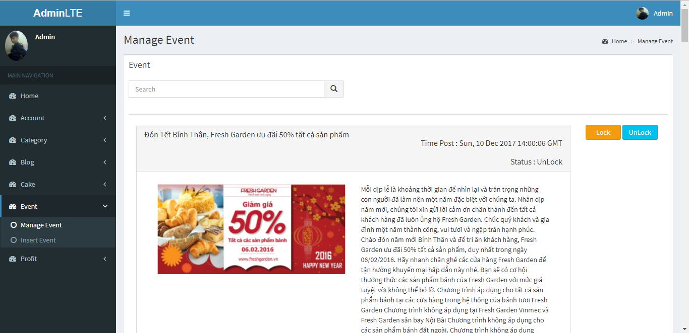

1. Manage Event screen
2. Manage Event

|  |  |  |  |  |  |  |
| --- | --- | --- | --- | --- | --- | --- |
| No | Field name | Type | Require | Mandatory | Max-Length | Description |
| 1 | Search | Text |  | Y |  | Search by name Event |
| 2 | Search (icon) | Button | Click | Y |  | Icon search |
| 3 | List Event | List |  | Y |  | List Event |
| 4 | Lock | Button | Click | Y |  | Lock Event |
| 5 | UnLock | Button | Click | Y |  | Unlock Event |

#### **Insert Event**

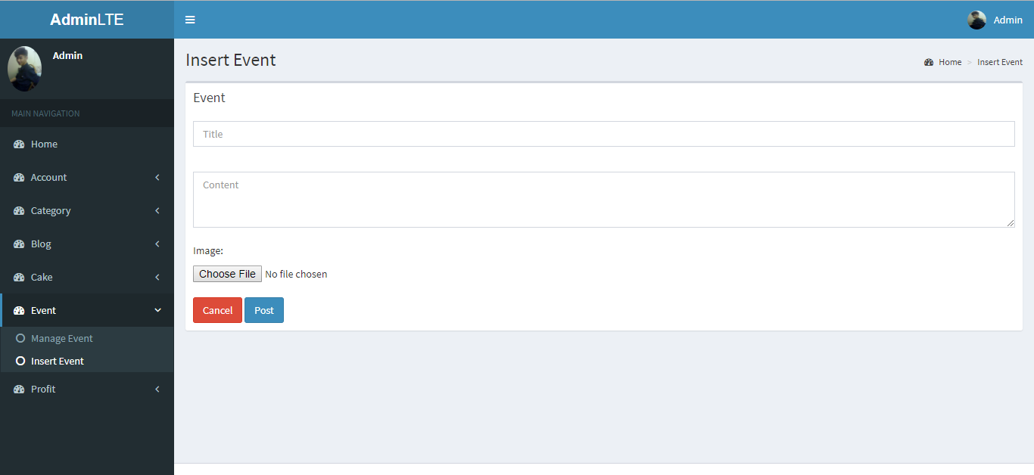

1. Insert Event screen

|  |  |  |  |  |  |  |
| --- | --- | --- | --- | --- | --- | --- |
| No | Field name | Type | Require | Mandatory | Max-Length | Description |
| 1 | Title | Text |  | Y |  | Title event |
| 2 | Content | Text |  | Y |  | Content event |
| 3 | Choose File | Button | Click | Y |  | Select Photo |
| 4 | Cancle | Button | Click | Y |  | Cancle and back to manage Event |
| 5 | Post | Button | Click | Y |  | Post Event |

1. Insert Event

### Profit

#### **Manage Bill**

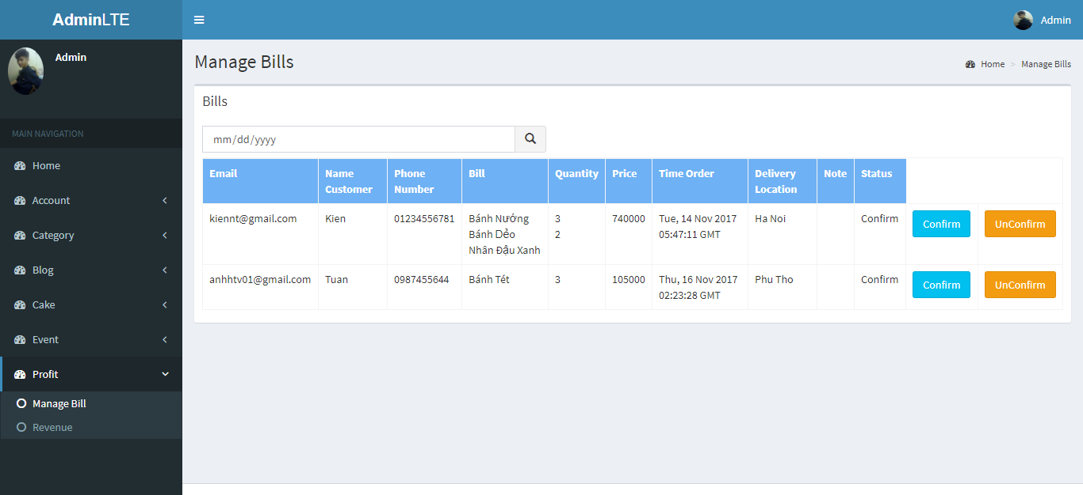

1. Manage Bill Screen

|  |  |  |  |  |  |  |
| --- | --- | --- | --- | --- | --- | --- |
| No | Field name | Type | Require | Mandatory | Max-Length | Description |
| 1 | Search | Date |  | Y |  | Search by date |
| 2 | Search (icon) | Button | Click | Y |  | Icon search |
| 3 | List Bill | Table |  | Y |  | List Bill |
| 4 | Confirm | Button |  | Y |  | Confirm bill |
| 5 | UnConfirm | Button |  | Y |  | UnConfirm bill |

1. Manage bill

#### **Revenue**

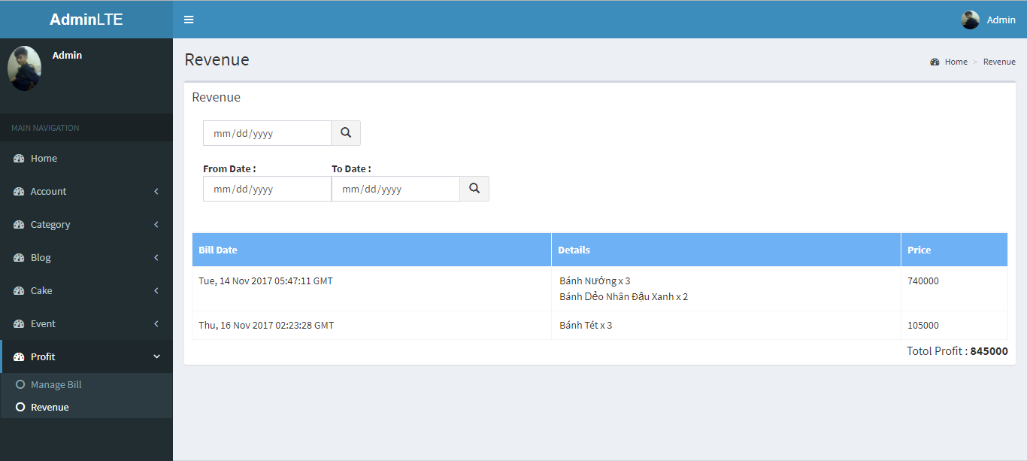

1. Revenue Screen

|  |  |  |  |  |  |  |
| --- | --- | --- | --- | --- | --- | --- |
| No | Field name | Type | Require | Mandatory | Max-Length | Description |
| 1 | Search | Date |  | Y |  | Search by date |
| 2 | Search (icon) | Button | Click | Y |  | Icon search |
| 3 | From Date | Date |  | Y |  | From Date |
| 4 | To Date | Date |  | Y |  | To Date |
| 5 | Search (icon) | Button | Click | Y |  | Icon search |
| 6 | List Bill | Table |  | Y |  | List Bill |

1. Revenue

#### **Change Password**

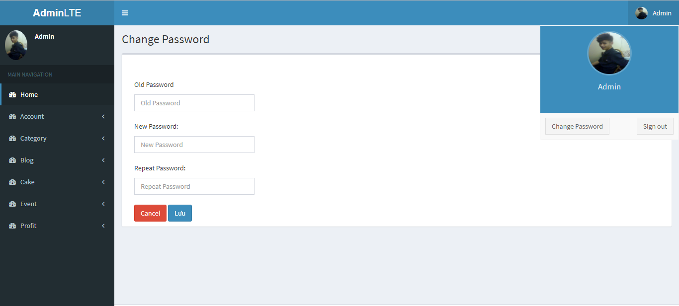

1. Change Password Screen

|  |  |  |  |  |  |  |
| --- | --- | --- | --- | --- | --- | --- |
| No | Field name | Type | Require | Mandatory | Max-Length | Description |
| 1 | Old Password | Text |  | Y |  | Old Password |
| 2 | New Password | Text |  | Y |  | New Password |
| 3 | Repeat Password | Text |  | Y |  | Repeat Password |
| 4 | Cancel | Button | Click | Y |  | Cancel |
| 5 | Change Password | Button | Click | Y |  | Change Password |

1. Change Password

## Staff

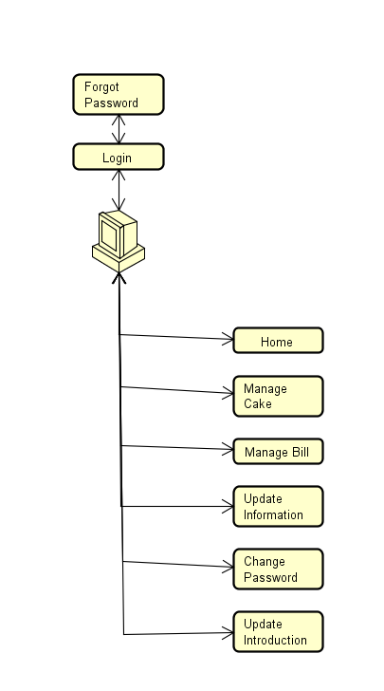

1. Staff screen flow

### **Sign In**

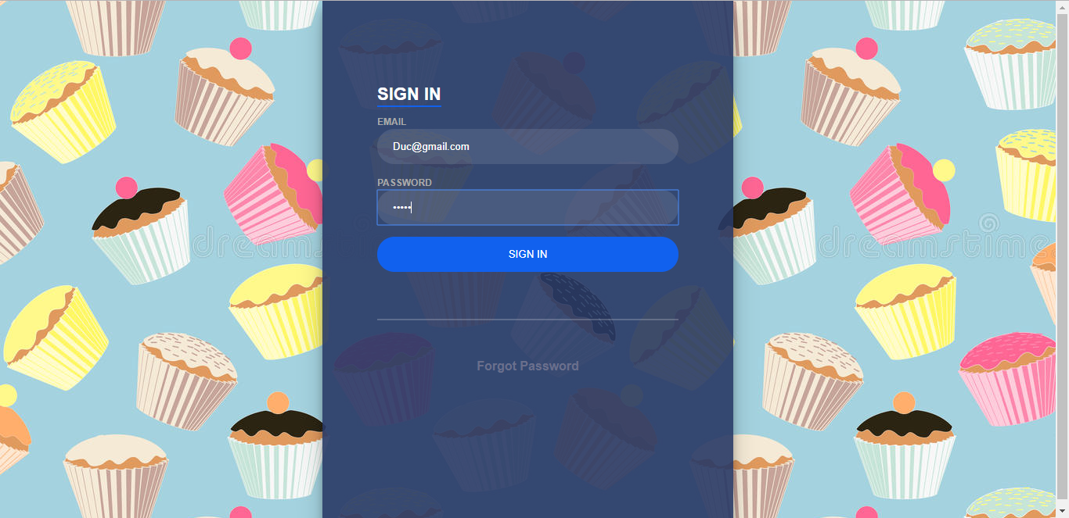

1. LoginStaff Screen

|  |  |  |  |  |  |  |
| --- | --- | --- | --- | --- | --- | --- |
| No | Field name | Type | Require | Mandatory | Max-Length | Description |
| 1 | Email | Text box | Email | Y |  | Email of Staff |
| 2 | Password | Text box | Type | Y |  | Password of Staff |
| 3 | Sign in | Button | Click | Y |  | Login |
| 4 | Forgot Pasword | Link | Click | Y |  | Forgot Password |

1. LoginStaff

### Forgot Password



1. Forgot Password screen

|  |  |  |  |  |  |  |
| --- | --- | --- | --- | --- | --- | --- |
| No | Field name | Type | Require | Mandatory | Max-Length | Description |
| 1 | Email | Text box | Email | Y |  | Email |
| 2 | Forgot Password | Button | Click | Y |  | Forgot password |
| 3 | Back to login | Link | Click | Y |  | Back to login |

1. Forgot Password

### Manage Cake

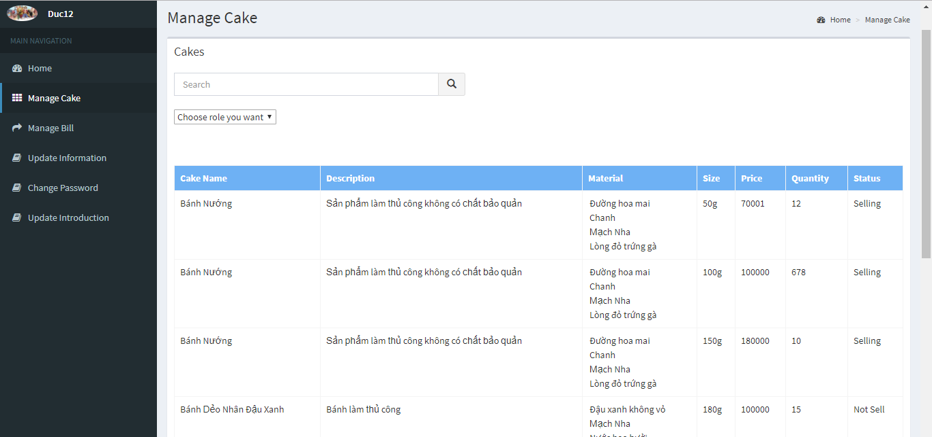

1. Manage Cake screen

|  |  |  |  |  |  |  |
| --- | --- | --- | --- | --- | --- | --- |
| No | Field name | Type | Require | Mandatory | Max-Length | Description |
| 1 | Search | Input Text |  | Y |  | Search by name |
| 2 | Icon Search | Button | Click | Y |  | Icon Search |
| 3 | Choose role you want | Drop Downlist | Click | Y |  | Search by role |
| 4 | List Cake | Table |  | Y |  | List Cake |

1. Manage Cake screen

### Manage Bill

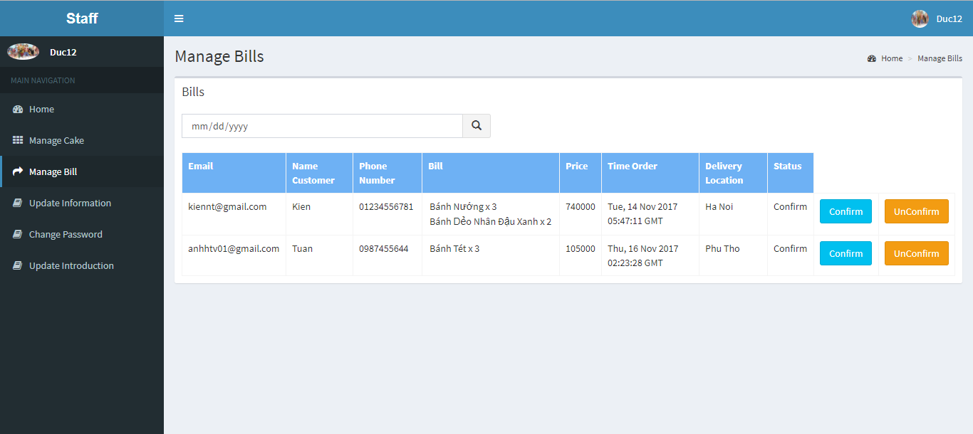

1. Manage Bill

|  |  |  |  |  |  |  |
| --- | --- | --- | --- | --- | --- | --- |
| No | Field name | Type | Require | Mandatory | Max-Length | Description |
| 1 | Search | Date |  | Y |  | Search by date |
| 2 | Search (icon) | Button | Click | Y |  | Icon search |
| 3 | List Bill | Table |  | Y |  | List Bill |
| 4 | Confirm | Button |  | Y |  | Confirm bill |
| 5 | UnConfirm | Button |  | Y |  | UnConfirm bill |

1. Manage Bill

### Update Information

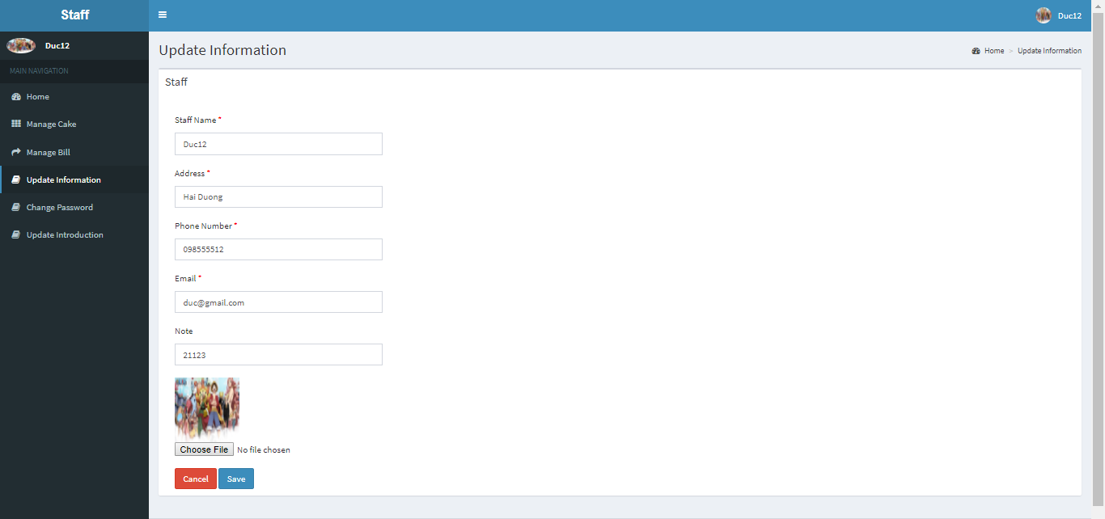

1. Update Information screen

|  |  |  |  |  |  |  |
| --- | --- | --- | --- | --- | --- | --- |
| No | Field name | Type | Require | Mandatory | Max-Length | Description |
| 1 | Staff Name | Text |  | Y |  | Staff Name |
| 2 | Addrees | Text |  | Y |  | Address Staff |
| 3 | Phone Number | Text |  | Y |  | Phone Number |
| 4 | Email | Text |  | Y |  | Email |
| 5 | Note | Text |  | Y |  | Other information |
| 6 | Choose File | Button | Click | Y |  | Select photo |
| 7 | Cancel | Button | Click | Y |  | Cancel |
| 8 | Save | Button | Click | Y |  | Save |

1. Update Information

### Change Password

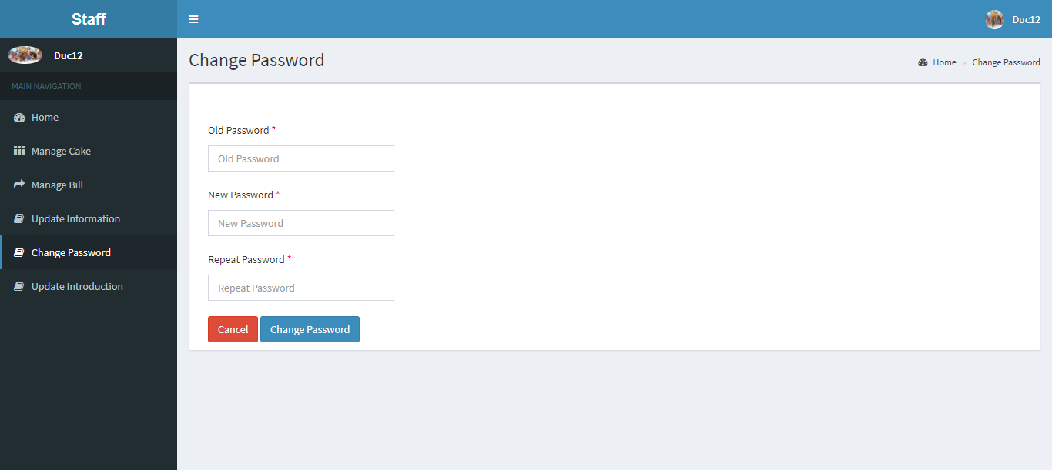

1. Change Password screen

|  |  |  |  |  |  |  |
| --- | --- | --- | --- | --- | --- | --- |
| No | Field name | Type | Require | Mandatory | Max-Length | Description |
| 1 | Old Password | Text |  | Y |  | Old Password |
| 2 | New Password | Text |  | Y |  | New Password |
| 3 | Repeat Password | Text |  | Y |  | Repeat Password |
| 4 | Cancel | Button | Click | Y |  | Cancel |
| 5 | Change Password | Button | Click | Y |  | Change Password |

1. Change Password

### Update Introduction

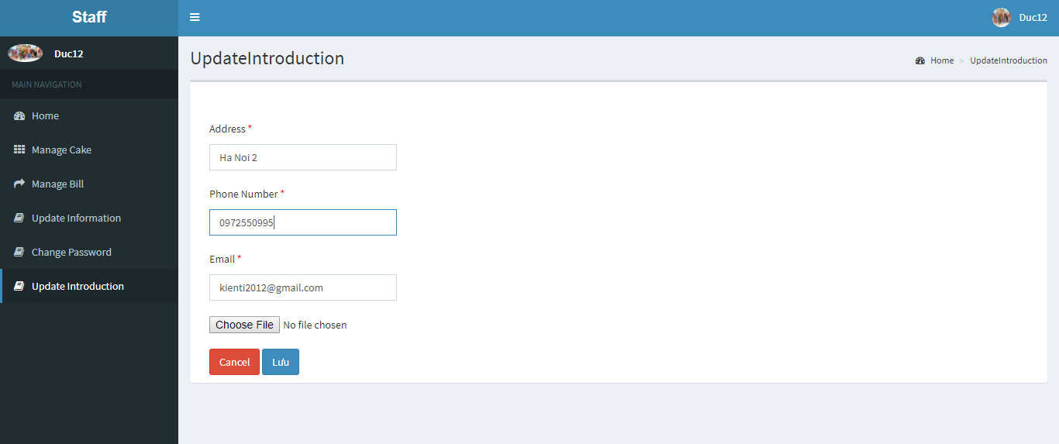

1. Update Introduction screen

|  |  |  |  |  |  |  |
| --- | --- | --- | --- | --- | --- | --- |
| No | Field name | Type | Require | Mandatory | Max-Length | Description |
| 1 | Address | Text |  | Y |  | Address your store |
| 2 | Phone Number | Text |  | Y |  | Phone Number |
| 3 | Email | Text |  | Y |  | Email |
| 4 | Choose File | Button | Click | Y |  | Map Photo |
| 4 | Cancel | Button | Click | Y |  | Cancel |
| 5 | Update | Button | Click | Y |  | Update |

1. Update Introduction